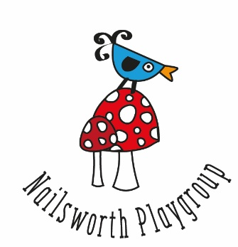
Application to Join Nailsworth Playgroup – Big Room
Full name of child:
Date of birth:
Name(s) and contact details of parent(s) making the application:
Name:  Address:  Postcode:  Mobile number:  Landline number:  Email: | Name:  Address:  Postcode:  Mobile number:  Landline number:  Email:

I/we would like our child to start Nailsworth Playgroup as soon as possible from……………………………….(date)
I/we would be interested in our child attending on the following sessions: (please tick)
Mon (incl lunch)  8.45-12.15 | Tues  8.45 - 11.45 | Weds (incl lunch)  8.45-12.15 | Thurs (incl lunch)  8.45-12.15 | Fri (incl lunch)  8.45-12.15
Mon 12.30 - 3.30 |  | Weds 12.30 - 3.30 | Thurs 12.30 - 3.30 | Fri 12.30 - 3.30
Mon (all day)  8.45 - 3.30 |  | Weds (all day)  8.45 - 3.30 | Thurs (all day)  8.45 - 3.30 | Fri (all day)  8.45 - 3.30
(We may not always be able to accommodate your choice of sessions, but it is helpful to know what you would like)
A £15 registration fee is requested (non-returnable) with the application form.
Admin: Fee received on………………………………….(date)
Signature of parent(s)
For us to be able to claim any extra nursery funding that your child may be entitled to e.g. Pupil Premium please supply the following information (you can decline as this is not a legal requirement):
Mother’s date of birth:

Mother’s National Insurance Number:
Thank you for completing the form
DATA PROTECTION: We, Nailsworth Playgroup, will only use the information you share with us to provide the playgroup services you have requested from us. The information will be kept securely and only shared where necessary to provide our playgroup services. Full details can be found in our Privacy Notice which is on our website and available at playgroup.
Nailsworth Playgroup

